УНИВЕРСИТЕТ ИТМО

Факультет программной инженерии и компьютерной техники

Направление подготовки 09.03.04 Программная инженерия

*Лабораторная работа №6 по*

*Администрированию систем и сетей*

Выполнили:

*Патутин Владимир*

*Крюков Андрей*

*P34101*

Преподаватель

*Афанасьев Дмитрий Борисович*

*Желаемая оценка: «3»*

Санкт-Петербург, 2022 г.

# 

Топология 3

Шаг 1. Настройте основные параметры устройств. 3

Шаг 2. Настройте параметры проводной сети. 3

Шаг 3. Настройте параметры точек доступа для выхода в сеть. 7

Шаг 4. Настройте параметры сервисов WLAN. 10

Проверка 11

# 

# Топология

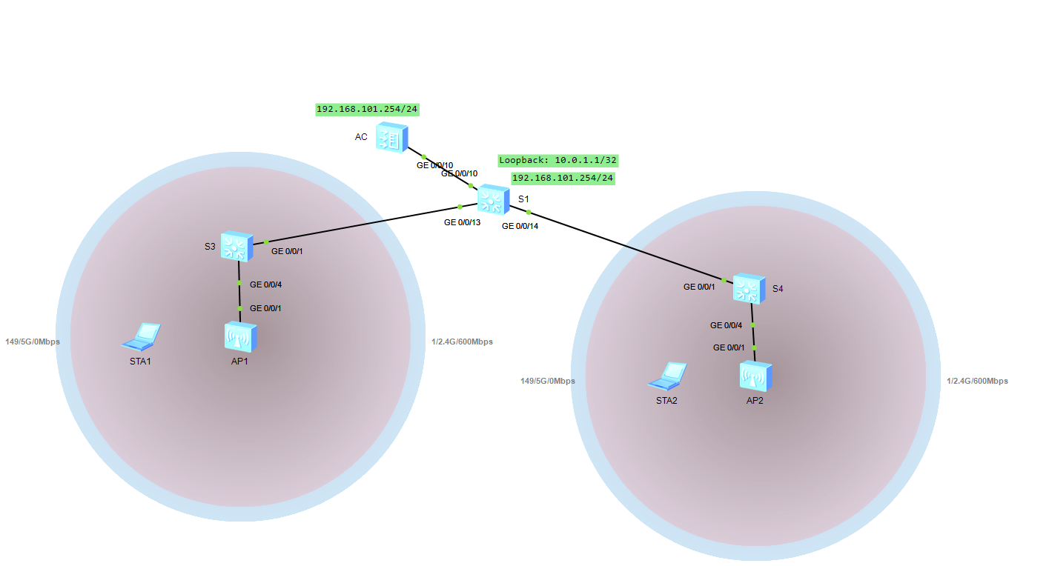

# Шаг 1. Настройте основные параметры устройств.

# Отключите ненужные порты между S1 и AC.

[S1] interface GigabitEthernet 0/0/11

[S1-GigabitEthernet0/0/11]shutdown

[S1-GigabitEthernet0/0/11]quit

[S1] interface GigabitEthernet 0/0/12

[S1-GigabitEthernet0/0/12]shutdown

[S1-GigabitEthernet0/0/12]quit

# Шаг 2. Настройте параметры проводной сети.

# Настройте VLAN

[S1]vlan batch 100 101

Info: This operation may take a few seconds. Please wait for a moment...done.

[S1]interface GigabitEthernet 0/0/13

[S1-GigabitEthernet0/0/13]port link-type trunk

[S1-GigabitEthernet0/0/13]port trunk allow-pass vlan 100 101

[S1-GigabitEthernet0/0/13]quit

[S1]interface GigabitEthernet 0/0/14

[S1-GigabitEthernet0/0/14]port link-type trunk

[S1-GigabitEthernet0/0/14]port trunk allow-pass vlan 100 101

[S1-GigabitEthernet0/0/14]quit

[S1]interface GigabitEthernet 0/0/10

[S1-GigabitEthernet0/0/10]port link-type trunk

[S1-GigabitEthernet0/0/10]port trunk allow-pass vlan 100 101

[S1-GigabitEthernet0/0/10]quit

[AC]vlan batch 100 101

Info: This operation may take a few seconds. Please wait for a moment...done.

[AC]interface GigabitEthernet 0/0/10

[AC-GigabitEthernet0/0/10]port link-type trunk

[AC-GigabitEthernet0/0/10]port trunk allow-pass vlan 100 101

[AC-GigabitEthernet0/0/10]quit

[S3]vlan batch 100 101

Info: This operation may take a few seconds. Please wait for a moment...done.

[S3]interface GigabitEthernet 0/0/1

[S3-GigabitEthernet0/0/1]port link-type trunk

[S3-GigabitEthernet0/0/1]port trunk allow-pass vlan 100 101

[S3-GigabitEthernet0/0/1]quit

[S3]interface GigabitEthernet 0/0/4

[S3-GigabitEthernet0/0/4]port link-type trunk

[S3-GigabitEthernet0/0/4]port trunk pvid vlan 100

[S3-GigabitEthernet0/0/4]port trunk allow-pass vlan 100 101

[S3-GigabitEthernet0/0/4]quit

[S4]vlan batch 100 101

Info: This operation may take a few seconds. Please wait for a moment...done.

[S4]interface GigabitEthernet0/0/1

[S4-GigabitEthernet0/0/1] port link-type trunk

[S4-GigabitEthernet0/0/1] port trunk allow-pass vlan 100 to 101

[S4-GigabitEthernet0/0/1]quit

[S4]interface GigabitEthernet0/0/4

[S4-GigabitEthernet0/0/4] port link-type trunk

[S4-GigabitEthernet0/0/4] port trunk pvid vlan 100

[S4-GigabitEthernet0/0/4] port trunk allow-pass vlan 100 to 101

[S4-GigabitEthernet0/0/4]quit

# Настройте IP-адреса интерфейсов.

[S1]interface Vlanif 101

[S1-Vlanif101]ip address 192.168.101.254 24

[S1-Vlanif101]quit

[S1]interface LoopBack 0

[S1-LoopBack0] ip address 10.0.1.1 32

[S1-LoopBack0]quit

[AC]interface Vlanif 100

[AC-Vlanif100]ip address 192.168.100.254 24

# Настройте DHCP.

[S1]dhcp enable

Info: The operation may take a few seconds. Please wait for a moment.done.

[S1]ip pool sta

Info:It's successful to create an IP address pool.

IP address pool for STAs

[S1-ip-pool-sta]network 192.168.101.0 mask 24

[S1-ip-pool-sta]gateway-list 192.168.101.254

[S1-ip-pool-sta]quit

[S1]interface Vlanif 101

[S1-Vlanif101]dhcp select global

[S1-Vlanif101]quit

[AC]dhcp enable

Info: The operation may take a few seconds. Please wait for a moment.done.

[AC]ip pool ap

Info: It is successful to create an IP address pool.

IP address pool for APs

[AC-ip-pool-ap]network 192.168.100.254 mask 24

[AC-ip-pool-ap]gateway-list 192.168.100.254

[AC-ip-pool-ap]quit

[AC]interface Vlanif 100

[AC-Vlanif100]dhcp select global

[AC-Vlanif100]quit

# Шаг 3. Настройте параметры точек доступа для выхода в сеть.

# Создайте группу AP и назовите ее ap-group1

[AC]wlan

[AC-wlan-view]ap-group name ap-group1

Info: This operation may take a few seconds. Please wait for a moment.done.

[AC-wlan-ap-group-ap-group1]quit

# Создайте профиль регулирующего домена и настройте код страны AC в профиле.

[AC]wlan

[AC-wlan-view]regulatory-domain-profile name default

[AC-wlan-regulate-domain-default]country-code cn

Info: The current country code is same with the input country code

[AC-wlan-regulate-domain-default]quit

# Установите привязку профиля регулирующего домена к группе AP

[AC]wlan

[AC-wlan-view]ap-group name ap-group1

[AC-wlan-ap-group-ap-group1]regulatory-domain-profile default

Warning: Modifying the country code will clear channel, power and antenna

gain configurations of the radio and reset the

AP. Continue?[Y/N]:y

[AC-wlan-ap-group-ap-group1]quit

# Укажите интерфейс-источник на AC для установления туннелей CAPWAP.

[AC]capwap source interface Vlanif 100

# Импортируйте точки доступа в AC и добавьте их в группу AP с именем ap-group1.

[AC]wlan

[AC-wlan-view]ap auth-mode mac-auth

[AC-wlan-view]ap-id 0 ap-mac 00E0-FCE1-19E0

[AC-wlan-ap-0]ap-name ap1

[AC-wlan-ap-0]ap-group ap-group1

Warning: This operation may cause AP reset. If the country code changes, it

will clear channel, power and antenna gain

configurations of the radio, Whether to continue? [Y/N]:y //Введите y для

подтверждения.

Info: This operation may take a few seconds. Please wait for a moment.. done.

[AC-wlan-ap-0]quit

[AC-wlan-view]ap-id 1 ap-mac 00E0-FCD0-3C00

[AC-wlan-ap-1]ap-name ap2

[AC-wlan-ap-1]ap-group ap-group1

Warning: This operation may cause AP reset. If the country code changes, it

will clear channel, power and antenna gain

configurations of the radio, Whether to continue? [Y/N]:y //Введите y для

подтверждения.

Info: This operation may take a few seconds. Please wait for a moment.. done.

[AC-wlan-ap-1]quit

# Выведите на экран информацию о текущей AP

[AC]display ap all

Info: This operation may take a few seconds. Please wait for a moment.done.

Total AP information:

nor : normal [2]

--------------------------------------------------------------------------------

--------------

ID MAC Name Group IP Type State STA Uptime

--------------------------------------------------------------------------------

--------------

0 00e0-fce1-19e0 ap1 ap-group1 192.168.100.190 AP9131DN nor 0 8M:7S

1 00e0-fcd0-3c00 ap2 ap-group1 192.168.100.186 AP9131DN nor 0 51S

--------------------------------------------------------------------------------

--------------

Total: 2

# Шаг 4. Настройте параметры сервисов WLAN.

# Создайте профиль безопасности HCIA-WLAN и настройте политику безопасности

[AC-wlan-view]security-profile name HCIA-WLAN

[AC-wlan-sec-prof-HCIA-WLAN]security wpa-wpa2 psk pass-phrase HCIA-Datacom

aes

[AC-wlan-sec-prof-HCIA-WLAN]quit

# Создайте профиль SSID HCIA-WLAN и задайте имя SSID HCIA-WLAN.

[AC]wlan

[AC-wlan-view]ssid-profile name HCIA-WLAN

SSID profile HCIA-WLAN is created.

[AC-wlan-ssid-prof-HCIA-WLAN]ssid HCIA-WLAN

The SSID name is set to HCIA-WLAN.

Info: This operation may take a few seconds, please wait.done.

[AC-wlan-ssid-prof-HCIA-WLAN]quit

# Создайте профиль VAP HCIA-WLAN, настройте режим передачи данных и сервисную

VLAN и примените профиль безопасности и профиль SSID к профилю VAP.

[AC]wlan

[AC-wlan-view]vap-profile name HCIA-WLAN

[AC-wlan-vap-prof-HCIA-WLAN]forward-mode direct-forward

[AC-wlan-vap-prof-HCIA-WLAN]service-vlan vlan-id 101

Info: This operation may take a few seconds, please wait.done.

[AC-wlan-vap-prof-HCIA-WLAN]security-profile HCIA-WLAN

Security profile HCIA-WLAN is bound.

Info: This operation may take a few seconds, please wait.done.

[AC-wlan-vap-prof-HCIA-WLAN]ssid-profile HCIA-WLAN

SSID profile HCIA-WLAN is bound.

Info: This operation may take a few seconds, please wait.done.

[AC-wlan-vap-prof-HCIA-WLAN]quit

# Установите привязку профиля VAP к группе AP и примените конфигурацию профиля

VAP HCIA-WLAN к радиомодулю 0 и радиомодулю 1 точек доступа в группе AP.

[AC]wlan

[AC-wlan-view]ap-group name ap-group1

[AC-wlan-ap-group-ap-group1]vap-profile HCIA-WLAN wlan 1 radio all

Info: This operation may take a few seconds, please wait...done.

[AC-wlan-ap-group-ap-group1]quit

# Проверка

Подключение к WLAN:

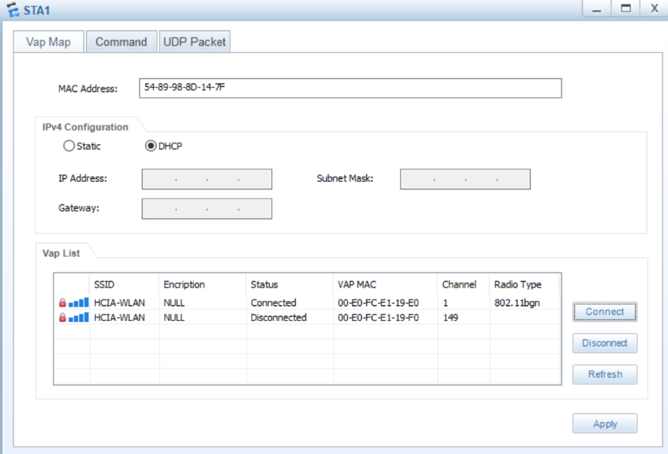

Проверка связи с S1:

STA>ping 10.0.1.1

Ping 10.0.1.1: 32 data bytes, Press Ctrl_C to break

From 10.0.1.1: bytes=32 seq=1 ttl=255 time=157 ms

From 10.0.1.1: bytes=32 seq=2 ttl=255 time=125 ms

From 10.0.1.1: bytes=32 seq=3 ttl=255 time=141 ms

From 10.0.1.1: bytes=32 seq=4 ttl=255 time=156 ms

From 10.0.1.1: bytes=32 seq=5 ttl=255 time=125 ms

--- 10.0.1.1 ping statistics ---

5 packet(s) transmitted

5 packet(s) received

0.00% packet loss

round-trip min/avg/max = 125/140/157 ms

Вывод команды “display station all” на AC:

[AC]display station all

Rf/WLAN: Radio ID/WLAN ID

Rx/Tx: link receive rate/link transmit rate(Mbps)

--------------------------------------------------------------------------------

----------------------

STA MAC AP ID Ap name Rf/WLAN Band Type Rx/Tx RSSI VLAN IP address SSID

--------------------------------------------------------------------------------------

5489-988d-147f 0 ap1 0/1 2.4G - -/- - 101 192.168.101.253 HCIA-

WLAN

--------------------------------------------------------------------------------

----------------------

Total: 1 2.4G: 1 5G: 0